

Cecil Andrews College

Year 11
ATAR
Human Biology

Test 4

DNA, Cell Reproduction
and Gene Expression

Name: _____________________Marking Key_____________________

Total Marks = 75

Section A. Multiple Choice (20 Marks)
Circle the most appropriate answer

Section B. Short Answer (45 Marks)
Write answers in the spaces provided

Section C. Extended Response (10 Marks)
Lined paper provided

SECTION A – Multiple Choice (Total 20 Marks)

- The base pairs found in DNA are:

  - A-C and T-G.
  - A-T and C-G.
  - A-G and C-T
  - A-U and C-G.

- Each chromosome contains:

  - one long DNA molecule.
  - one long RNA molecule.
  - one long sequence of amino acids.
  - a single gene for a protein.

- Which of the following is true for most genes?

  - A gene is a segment of DNA that contains the instructions for making a particular protein.
  - A gene is a segment of DNA that contains the instructions for making a particular RNA.
  - A gene is a region of DNA that controls a discrete hereditary characteristic of an organism.
  - All of the above.

- The DNA in chromosomes is condensed into a compact form by interactions with:

  - RNA.
  - proteins.
  - microtubules.
  - centromeres.

- A DNA strand with the sequence AACGTAACG is transcribed. What is the sequence of the mRNA molecule synthesised?

  - AACGTAACG.
  - UUGCAUUGC.
  - AACGUAACG.
  - TTGCATTGC.

- Which of the following correctly compares mitosis and meiosis in humans?

  - Mitosis involves the production of two identical cells; meiosis produces four different cells.
  - Mitosis requires two nuclear divisions; meiosis requires four nuclear divisions.
  - Mitosis is only for growth; meiosis is for reproduction.
  - Mitosis stops at adulthood; meiosis begins at puberty.

- Which of the following sequences accurately describes protein synthesis?

  - mRNA →Amino acid→tRNA→DNA.
  - mRNA→DNA→tRNA→Amino acid.
  - DNA→mRNA→Amino acid→tRNA.
  - DNA→mRNA→tRNA→Amino acid.

- The basic building blocks which make up DNA are called:

  - nucleotides
  - amino acids
  - nitrogenous bases
  - monosaccharides.

- The process of copying a gene’s DNA sequence into a sequence of RNA is called:

  - replication.
  - transcription.
  - translation.
  - PCR.

- The process of DNA making a complete copy of itself is called?

  - Replication
  - Synthesis
  - Transcription
  - Translation

- Cytokinesis is associated with:

- meiosis.
- mitosis.
- both mitosis and meiosis.
- neither mitosis nor meiosis.

- Translation is the process in which:

  - DNA is formed on DNA template.
  - DNA is formed on RNA template.
  - protein is formed on DNA template.
  - protein is formed on RNA template.

- The anticodon of tRNA binds with:

  - nucleic bases of mRNA.
  - codons of mRNA.
  - nucleic bases of rRNA.
  - amino acid.
- If the tRNA anticodon is AUG then the DNA triplet is:

  - TUG.
  - UAC.
  - AUG.
  - ATG.

- Transcription occurs in the:

  - nucleus.
  - cytoplasm.
  - cytosol.
  - ribosome.

- Replication of DNA occurs during which phase of the cell cycle?

  - G₁
  - S
  - G₂
  - M

- When sex cells undergo meiosis, the daughter cells produced contain:

  - the haploid number of chromosomes.
  - the diploid number of chromosomes.
  - the replicate number of chromosomes.
  - the same number of chromosomes as the parent cells.

- The importance of mitochondrial DNA is that it directly codes for enzymes which are directly involved in the process of:

  - protein synthesis
  - endocytosis
  - nuclear division
  - respiration

- If an organism produces an egg cell containing 20 chromosomes, the number of chromosomes in the body cells of the organism would equal:

  - 10.
  - 20.
  - 40.
  - impossible to determine from the information.

- Mitosis is a dynamic process. The stages of mitosis in correct order are as follows:
  - anaphase, telophase, interphase, prophase, metaphase.
  - metaphase, anaphase, interphase, telophase, prophase.
  - interphase, metaphase, prophase, telophase, anaphase.
  - interphase, prophase, metaphase, telophase, anaphase.
SECTION B – Short Answer

- Label the following diagram.

Sugar & phosphate
adenine & thymine
cytosine & guanine
½ mark each

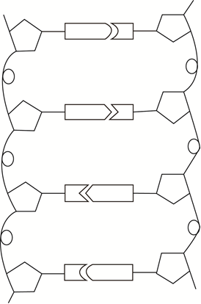

(3 Marks)

- The research of Erwin Chargaff was essential in the discovery of the structure of DNA. Chargaff analysed the base composition of DNA from a range of organisms. He reported his findings using the initial letter of each base to stand for the number of that base found in an organism’s genome.

A = number of adenine bases G = number of guanine bases
C = number of cytosine bases T = number of thymine bases

  - Which of these relationships did he find within the genome of each organism he studied? (Circle the correct response)

A = G C = T A + T = C + G A + G = T + C A = C G = T

  - Explain your answer
A is complementary to T and G is complementary to C. The number of Adenine bases is equal to the number of Thymine bases. Therefore, the number of Adenine bases PLUS the number of Guanine bases is equal to the number of Thymine bases PLUS the number of Cytosine bases. (2 Marks)
- What is the production of mRNA called and what enzyme catalyses this process?

_____Transcription (1) RNA polymerase (1)_______________________(2 Marks)

- In relation to stem cells, describe what ‘differentiation’ means.

The process by which cells, tissue and organs acquire specialised features, especially during embryonic development (2 Marks)

- Uncontrolled division of cells can result in an abnormal mass of tissue called a tumour. Explain the difference between malignant and benign.

A benign tumour is contained within a membrane which prevents the abnormal cells from migrating to other parts of the body.
A malignant cancer has no confining membrane. The cancerous cells may spread to other parts of the body. This process is called metastasis and can result in secondary tumours. The cells may move in the lymphatic system or the blood’s circulatory system (2 Marks)

- Cells which are undergoing mitosis can be ‘fixed’ and stained so that their chromosomes can be viewed with the aid of a microscope. Describe how you would distinguish between the following:

  - cells in interphase and cells in prophase;

- interphase: chromosomes not visible, nuclear membrane intact
- prophase: chromosomes become visible, nuclear membrane beginning to break down
(2 Marks)

  - cells in metaphase and cells in anaphase.

- metaphase: chromosomes lined up across the centre of the cell
- anaphase: centromere divided and chromosome halves being pulled by spindle towards the poles of the cell
(2 Marks)
- What do the letters DNA represent?

deoxyribose nucleic acid
(2 Marks)

- Name the process illustrated in the diagrams below. ___Meiosis___________(1 Mark)

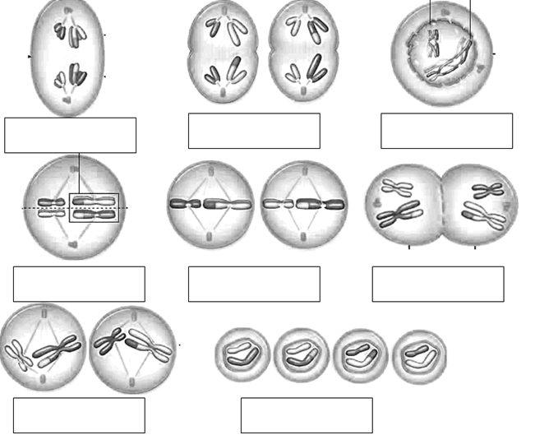

- The diagrams above are not in the correct order. Label them to indicate the names of the phases shown and the order in which they occur. (6 Marks)

- The two types of cells produced by the process shown above are:

  - ____sperm________________________
  - ____ovum______________________ (2 Marks)

- Why is the above process necessary before gametes fuse in fertilisation?
- to reduce the chromosome number from the diploid number to the haploid number.
- at fertilisation the zygote will then have the diploid number of chromosomes
(2 Marks)

- Define epigenetics.
The study of changes in organisms caused by modification of gene expression rather than alteration of the genetic code itself. (2 Marks)

- Describe how protein synthesis is related to the synthesis of lipids.
- enzymes produced by protein synthesis control the synthesis of lipids (2 Marks)
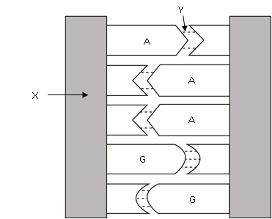

- In the diagram at right:

  - What type of bond is Y?

Hydrogen (weak) (1 Mark)

  - What are the two components of part X?
ribose sugar and phosphate molecule
(2 Marks)

- Describe two ways in which a tRNA molecule is different to a DNA molecule.
- single strand compared to double strand of DNA
- contains nitrogenous base uracil instead of thymine

(2 Marks)
- Describe the role of spindle fibres during cell division.
- attach to centromere, contract and pull the chromosomes towards the poles of the cell
(2 Marks)

- Label the diagrams of the male and female reproductive systems as indicated below:

urethra
penis
prostate
urinary bladder
ureter
seminal vesicle
rectum
vas deferens
epididymis
testis/testicle
½ mark each

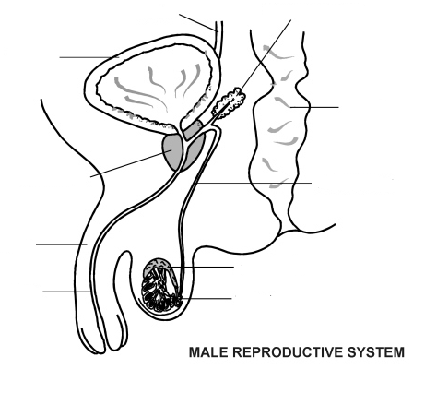

(5 Marks)
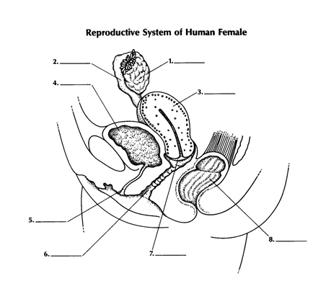
ovary
uterine tube (fallopian)
uterus
urinary bladder
urethra
vagina
cervix
rectum
½ mark each

(4 Marks)
SECTION C – Extended Response (10 Marks)

There are two (2) questions, you are required to answer one of them. Clearly label your choice.

- Mitosis and meiosis are both forms of cell division but they are not the same process. Compare and contrast them, using diagrams where appropriate.

1 MARK EACH FOR:

Mitosis | Meiosis
Sexual | Asexual
Diploid | Haploid
Body cells | Gametes
1 round of division | 2 rounds of division
2 identical daughter cells | 4 unique daughter cells
No homologous pairs | Homologous pairs
No crossing over can occur | Crossing over
 | Random assortment
 | Non-disjunction
 | Mutation more likely in meiosis

- Living organisms use DNA as their genetic material. Outline how DNA is replicated within the cells of living organisms.
- DNA – double helix structure, two strands or nucleotides

- DNA unzips along its entire length
  - DNA Helicase enzyme
  - Disrupts hydrogen bonding
  - Separates strands into Y-shape known as the replication fork
- DNA directional in both strands (bi-directional)
  - 5’ end and 3’ end
    - 5’ end has a phosphate (P) group attached
    - 3’ end has a hydroxyl (OH) group attached
  - Leading strand – 3’ to 5’
  - Lagging strand – 5’ to 3’
- Leading strand
  - Primer (generated by DNA primase) binds to the 3’ end of the strand
- Elongation – DNA polymerase binds at the site of the primer and begins adding new base pairs complementary to the strand
- Lagging strand
  - Multiple primers
  - DNA polymerase then adds pieces of DNA (Okazaki fragments) to the strands
- Free nucleotides from the nucleoplasm fill the exposed nitrogen bases
- Nucleotide consists of sugar and phosphate molecule and a nitrogenous base
- Base-pairing rules
  - Adenine – Thymine, Cytosine – Guanine
- Nucleotide with nitrogenous base Adenine pairs with complementary base Thymine
- Two identical copies are held together by a centromere molecule
- This process occurs during the later stages of interphase in both meiosis and mitosis

